# Rice Mill Consumer Management System

## Project Overview

The **Rice Mill Consumer Management System** is a Salesforce-based application that helps manage consumers, rice details, transactions, and reports for a rice mill company. It provides role-based access and automates consumer notifications and reporting.

## Key Features:

* **Consumer Management**: Tracks consumer information, including name, email, and rice consumption.
* **Rice Management**: Manages rice types, pricing, and availability.
* **Payment Tracking**: Records transaction details, such as amounts paid and modes of payment.
* **Role-Based Access**: Different user roles (Owner, Employer, Worker) with custom access to records.
* **Automated Email Notifications**: Sends a welcome email to consumers when they are registered.
* **Reports & Dashboards**: Generate insights into rice sales and payments.
* **Custom Object Permissions**: Controls access to consumer, rice, and transaction records based on user profiles.

## System Design

### 1. Object Structure

* **Consumer**: Stores consumer details like name, email, and rice consumption.
* **Rice Details**: Contains rice type and price information.
* **Transaction**: Tracks payments, modes of payment, and transaction amounts.

### 2. Page Layouts & Profiles

#### Page Layouts:

* **Consumer Layout**: Includes sections for personal information, rice orders, and payment details.

#### Profiles:

* **Owner Profile**: Full access to all data.
* **Employer Profile**: Restricted access to rice and consumer data.
* **Worker Profile**: Limited access to transaction-related data.

### 3. Role Hierarchy

* **Owner**: Top-level role with access to all records.
* **Employer**: Access to consumer and transaction data.
* **Worker**: Limited access to basic transaction data.

## Apex Class and Trigger

### 1. Apex Class: ConsumerRecord

This class sends a welcome email to consumers upon record creation.

***public class ConsumerRecord {***

***public static void sendEmailNotification (List<consumer__c> con){***

***for(consumer__c c:con)***

***{***

***Messaging.SingleEmailMessage email = new Messaging.SingleEmailMessage();***

***email.setToAddresses( new List<String>{c.email__c});***

***email.setSubject('Welcome to our company');***

***email.setPlainTextBody('Dear ' + ' '+ ',\n\nWelcome to MY RICE!'+'You have been seen as a valuable customer to us. PLease continue your journey with us, while we try to provide you with good quality resources.'+'\n'+***

***'We are proud to associate with valuable customers like you, and we look forward to collaborating with you by providing more and more exciting discounts or even product offers too.' + '\n'***

***+'So why taking a step back, take a leap of faith and shop with us more, while we provide with the valuable products and offers'+'\n'+'\n'+'\n'+***

***'Thankyou for buying '+ '' +'Here are some of the products that are brought by the customers who similarly bought products like this'+'\n\n');***

***Messaging.sendEmail(new List<Messaging.SingleEmailMessage>{email});***

***}***

***}***

***}***

### 2. Apex Trigger: consumerTrigger

The trigger calls the sendEmailNotification method after a consumer is inserted into the system.

***trigger consumerTrigger on consumer__c (After insert) {***

***if(trigger.isAfter && trigger.isInsert) {***

***ConsumerRecord.sendEmailNotification(trigger.new);***

***}***

***}***

## Reports and Dashboards

### 1. Report: Range of Amount Per Day

The report tracks the daily spending of consumers, with the following fields:

* **Consumer name**
* **Rice type**
* **Rice price/kg**
* **Mode of payment**
* **Amount paid**

The report is grouped by **Rice taken by shops**.

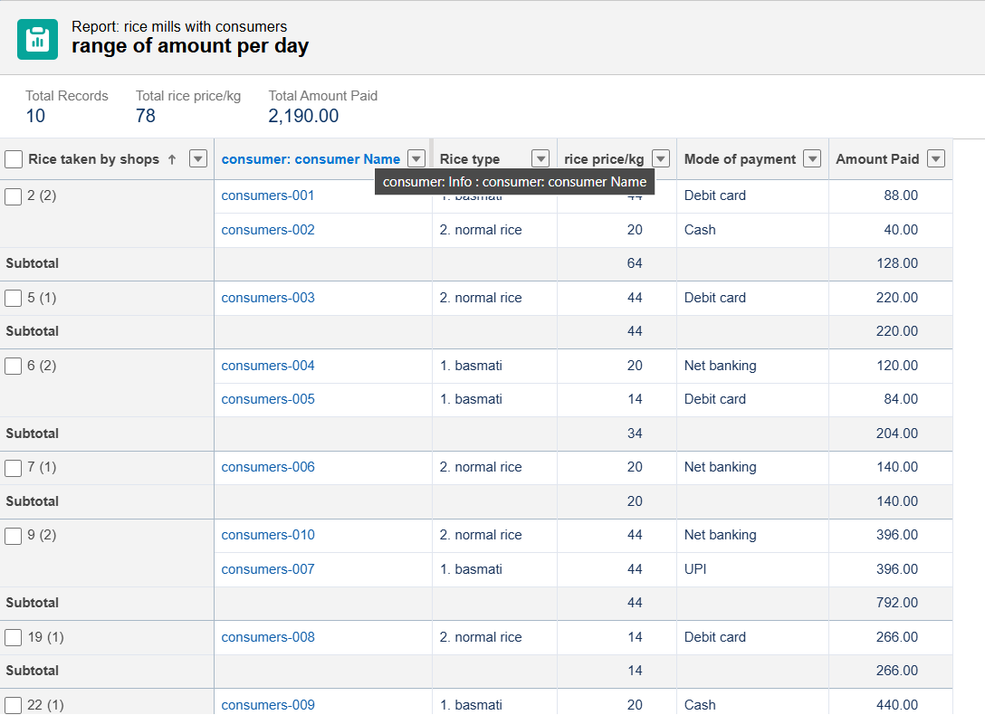

### 2. Dashboard: Amount Data Dashboard

This dashboard visualizes the daily amount spent by consumers, with:

* **Vertical Bar Chart**: Shows the total amount spent per shop.
* **Donut Chart**: Displays the range of amounts spent.

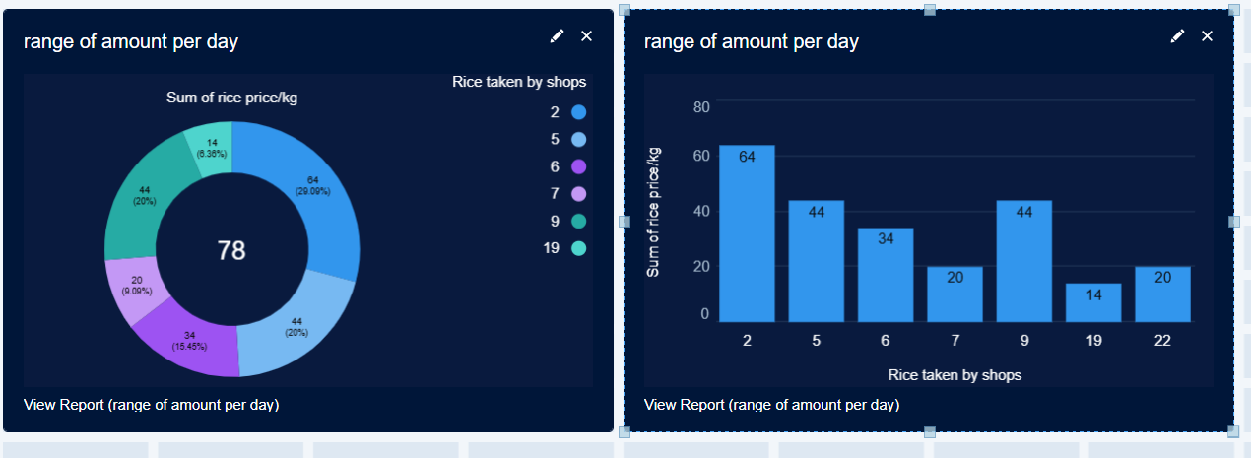

## User Creation Process

1. Go to **Setup** and search for **Users**.
2. Click **New User** and fill in:
   * First name, last name, email, username, and role.
   * Assign the appropriate **profile** and **user license** (Salesforce or Salesforce Platform).

## Conclusion

The **Rice Mill Consumer Management System** is a robust Salesforce solution designed to help rice mills manage consumer data, transactions, and reports effectively. With features like automated email notifications, role-based access control, and detailed reporting, the system simplifies consumer management and improves operational efficiency.